.
C4 Model Practice 2: Currency Exchange

.
We are reverse-engineering the structural blueprints for Kurrency, the currency conversion mobile application shown in your exam prompt.
The Scenario: Currency Exchange Mobile Application
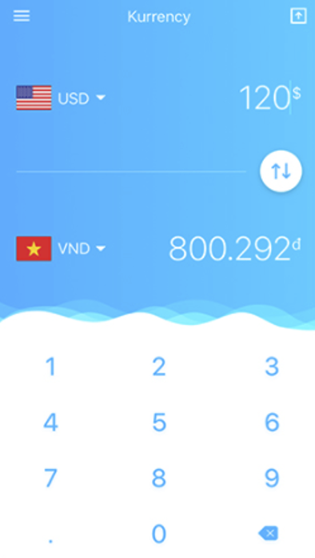

Assume that the exchange rate can be retrieved from currency web service (online). The application converts the money by submitting the amount of money and currency from both sides. At a glance, an interactive custom keypad, two currency drop-downs (USD and VND), a swap toggle, and real-time converted fields ( 800,292₫).
Let's look at the complete, multi-tiered C4 Model design for this platform.

.

🟢 Level 1: System Context Diagram

.
Objective: Visualize the boundary of the Kurrency System, identifying how the human user and external financial dependencies interact with it at a macro scale.

Step-by-Step Task Instructions
- Identify the Actor: The smartphone user inputting currency figures.
- Define the External System: The third-party Online Currency Web Service (e.g., Fixer.io, Open Exchange Rates).
- Draw Boundaries: Represent the Kurrency ecosystem as a single system block, ignoring internal mechanics for now.

.

Solution Diagram

.
Mermaid.js

Diagram

.

🟡 Level 2: Container Diagram

.
Objective: Zoom inside the system boundary.
⚠️ Professor's Engineering Warning: Do not connect the Mobile App directly to the external third-party API in a production system. If you embed private API access keys directly within a client binary, malicious actors will decompile the application and steal your billing tokens within minutes. We must decouple this with a secure Backend API container and an In-Memory Cache to store rates locally for up to an hour, keeping external API consumption costs low.

Step-by-Step Task Instructions
- Identify Frontend Containers: Create a dedicated Mobile Client Application.
- Identify Backend Containers: Create an intermediate Backend API Gateway to act as a secure proxy.
- Incorporate Data Storage: Introduce an In-Memory Rate Cache container to manage high-speed key-value lookups.

.

Solution Diagram

.
Mermaid.js

Diagram

.

🔴 Level 3: Component Diagrams

.
Let's zoom directly into our containers to expose their modular structural blocks.

.

Component Diagram: 1. Kurrency Mobile App Container Components

.
Objective: Decompose the client-side engine running on the smartphone to see how user clicks translate to network triggers.

Step-by-Step Task Instructions
- Isolate View Components: Break down the UI elements matching the prompt picture (Keypad, Dropdown Selector, Display Fields).
- Design the Core Controller: Place a calculation/state coordination engine in the center to manage dynamic calculation states.
- Isolate the Infrastructure Client: Establish an independent HTTP engine to make external queries.

.

Solution Diagram

.
Mermaid.js

Diagram

.

Component Diagram: 2. Secure API Backend Gateway Container Components

.
Objective: Decompose the backend proxy server to understand how requests are validated, processed, and optimized.

Step-by-Step Task Instructions
- Map Inbound Endpoints: Define the controller listening to incoming traffic frames.
- Build the Integration Engine: Isolate the logical component whose sole task is fetching and mapping raw currency matrix schemas.
- Connect Storage Accessors: Link the logic handlers to the local memory cache client driver.

.

Solution Diagram

.
Mermaind.js

Diagram

